







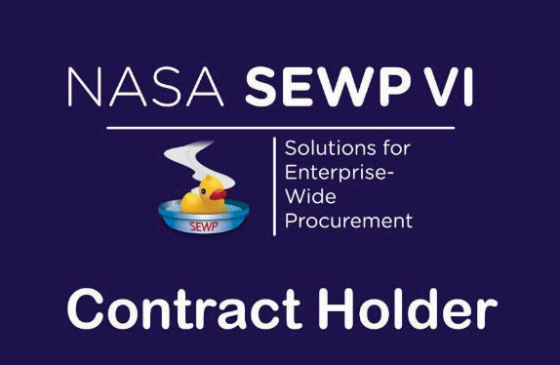

iGov Technologies, Inc.
Category A Contract
80TECH26D2069
PoP: November 1, 2026 – October 31, 2036

Main Office Address: iGov Technologies, Inc.
405 Van Buren Street, Suite 440
Herndon, VA 20170 Phone: 703-356-1160
CAGE Code: 32BQ5
UEI: JKJ7JTLJJHR6
NAICS Code: 541519e (Footnote 18 ITVAR)

SEWP VI Program Support
Order Issues and Post-Delivery Contacts
Phensopa Swope SEWP Program Manager

Theresa Whittle
SEWP Deputy Program Manager

igovcontracts@igov.com
(703) 356-1160
SEWP Helpline

help@sewp.nasa.gov
(301) 286-1478
SEWP PMO Hours:
M-F, 7:30 AM – 6 PM (ET)
www.sewp.nasa.gov

SEWP OVERVIEW

NASA SEWP VI – The NASA SEWP (Solutions for Enterprise-Wide Procurement), pronounced "soup", provides the latest Information Technology, Communication, and Audio-Visual (ITC/AV) solutions and services for all Federal Agencies and their approved contractors. Created in 1993, SEWP I was the first Government-Wide Acquisition Contract (GWAC) in the federal acquisition space. Originally, the contract vehicle provided only technology products for NASA and all other agencies. SEWP has continually evolved over the past 30 years, expanding its scope to meet the requests of its customers. The SEWP vehicle represents acquisition innovation within the Federal Government. The program is self-funded through usage fees (0.34%) and provides all Federal agencies with acquisition support - more than 50,000 orders a year.
ABOUT IGOV TECHNOLOGIES INC
iGov Technologies Inc. is a small business, IT Value-Added Reseller (VAR) and systems integrator. iGov provides commercial IT products and solutions, along with engineering and management services to help our government customers meet their mission-critical program needs. We are a trusted provider with over 20 years of federal contracting experience. We have cultivated relationships with strategic OEM partners, suppliers, and technology distributors to ensure government customers receive innovative products and services through a secure supply chain. As a systems integrator, we specialize in the design, development, testing, production, and sustainment of Tactical Data Systems. iGov is ISO 9001:2015 and O-TTPS 1.1.1 (ISO/IEC 20243:2018) certified.
Visit our website: https://igov.com/






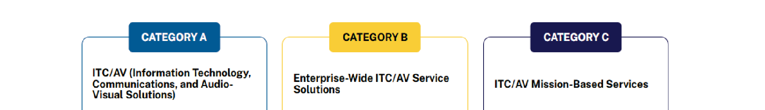
WHAT’S IN SCOPE FOR SEWP VI?

SEWP is designed to provide a broad suite of Information Technology, Communication and Audio Visual (ITC
/ AV) solutions and services. Technology is ever-evolving and for that reason SEWP's processes enable our Contract Holders to add new commercial technology and IT services to their contract daily, as requested by our customers. The focus of SEWP is on the full suite of technology offerings that simplify Governmental access and Industry offerings across the entire ITC/AV solutions and services landscape. SEWP is composed of three (3) scope categories detailed below. If you would like SEWP to determine if your requirement is within scope of the SEWP VI contract, please send an overview and/or bill of materials (BOM) to help@sewp.nasa.gov and we will quickly review and provide feedback.

The SEWP Contracts were awarded by scope category, the three categories are:
- Category A - ITC/AV Solutions
- Category B - Enterprise-Wide ITC/AV Service Solutions
- Category C - Mission-Based ITC/AV Service Solutions

FAIR OPPORTUNTIY

Contracts will be provided a fair opportunity at the individual order level as appropriate per FAR 16.505(b), including the SEWP RFQ tools. No documentation for the order selection is required to be submitted with the order. All such documentation is to be maintained by the issuing procurement office. Using the SEWP online Quote Request Tool is the recommended method to assist in this activity and to augment the required decision documentation. The SEWP Quote Request Tool (QRT) will automatically include the Contract Holders within a selected Group or based on a suggested source.

ORDERING PROCESS

The internal ordering process of each Agency varies. The process and accompanying forms for Purchase Requests (PR) and Delivery Orders (DO) that are issued against a SEWP contract is defined by the issuing Agency, not the NASA SEWP Program Management Office (PMO). The typical process is for an end-user to determine a requirement and generate a Purchase Request (PR).

The PR along with any necessary funding information is sent to that Agency's procurement office which results in the issuance of a DO. Any valid Federal Agency DO form, and the associated Delivery Order number may be used. The NASA SEWP Program Management Office (PMO) does not issue DOs - these must be issued through the issuing Agency's procurement office. The SEWP Program Management Office (PMO) reviews, processes and tracks issued DOs and forwards them to the Contract Holder(s).

Some Agencies have special requirements for issuing IT Delivery Orders. It is the Issuing Agency's Contracting Oficers' (COs/KOs) responsibility to be aware of any Agency-specific policies regarding issuing orders via an existing contract vehicle and Government-Wide Acquisition Contracts. There are no requirements under the SEWP Contracts for issuing Agencies to use other intermediary procurement offices, except as directed through their own internal policies.

If modifications are made to any order, these modifications must also route through the SEWP Program Management Office (PMO).

HOW TO OBTAIN A QUOTE

To obtain a quote for hardware, software, or services, customers can use the SEWP Quote Request Tool. Customers can use this tool to issue a Request‐For‐Information (RFI), Request‐For‐Quote (RFQ), Market Research Request (MRR).

Customers may also obtain a quote by contacting iGov’s sales representatives at salesstaff@igov.com or
1‐800‐777‐9375.

POLICY AND PROCEDURAL INFORMATION

Ordering Process
- Customer sends order to SEWP Program Management Office (PMO), sewporders@sewp.nasa.gov or fax order and SEWP Fax Cover Sheet to: (301) 286‐0317, www.sewp.nasa.gov
- SEWP PMO reviews and enters the order information into SEWP database and assigns SEWP Control Number (SCN)
- SEWP PMO sends the order to iGov Technologies, Inc.
- iGov Technologies, Inc. acknowledges receipt of order
- iGov Technologies, Inc. begins fulfillment of order

Warranty
In accordance with iGov’s SEWP contract, iGov shall provide an extended warranty, which can be purchased and begin at any time during the standard commercial warranty period up to and including the end of the commercial warranty period. Extended warranty packages may be invoiced and paid at the start of the warranty period. This extended warranty shall provide coverage based on the standard commercial warranty.

At the Government’s discretion, the Government may order, at any time during a warranty period, monthly maintenance at a Discounted Monthly Extended Warranty amount in lieu of the extended warranty.

Software Maintenance / Product Extended Warranty as a Product
Product and software maintenance, warranty and licensing shall be treated as a commercial product unless such product is priced on a usage basis; e.g. maintenance on a printer based on usage must be invoiced monthly.
Software maintenance as a product includes the publishing of bug/defect fixes via patches and updates/upgrades in function and technology to maintain the operability and usability of the software product. It may also include other no charge support that is included in the purchase price of the product in the commercial marketplace. No charge support includes items such as user blogs, discussion forums, on‐line help libraries and Frequently Asked Questions (FAQ), hosted chat rooms, and limited telephone, email and/or web‐based general technical support for users self diagnostics.

Software maintenance as a product does NOT include the creation, design, implementation, integration, etc. of a software package. These examples are considered software maintenance as a service and are to be billed monthly.

